 |  | Bootstrap
Parameter | Final Model estimates (%RSE) [%shrinkage] | Median | 95% CI
Typical Values
CL (L/h) | 8.31 (7%) | 8.33 | 7.52 - 9.16
V1 (L) | 56.1 (15.2%) | 56.2 | 47.3 - 65.9
V2 | 44 (4.4%) | 43.9 | 39.5 - 48.0
Q (L/h) | 20.6 (13.1%) | 20.5 | 18.1 - 23.0
Kd | 0.0414 (6.3%) | 0.04 | 0.0338 - 0.0503
N | 0.84 (4.5%) | 0.84 | 0.77 - 0.93
Covariate effect
EGFR on CL | 1.59 (7.8%) | 1.59 | 1.42 - 1.77
Interindividual variability
CL | 0.0991 (40.1%) [1%] | 0.09 | 0.0622 - 0.1303
V1 | 0.28 (43.6%) [3%] | 0.27 | 0.19 - 0.37
Residual variability
Proportional error | 0.0464 (3.2%) [3%] | 0.0457 | 0.0397 - 0.0541
Nota:

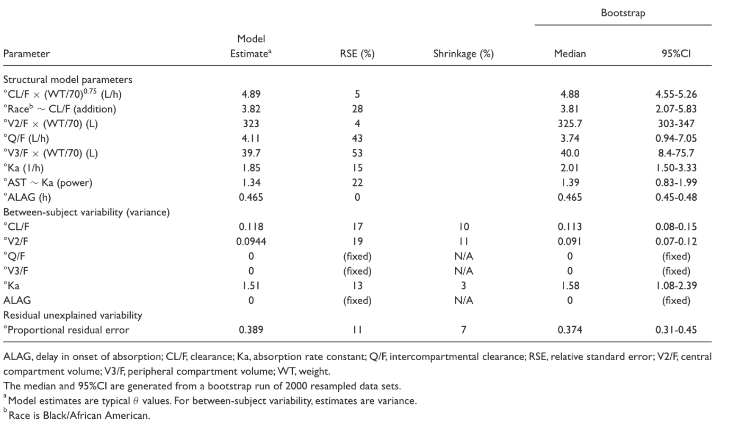

EGFRCL = THETA(1)

; exponents for covariates
TVCL = THETA(2)
CL = TVCL * (eGFR/90)**EGFRCL * EXP(ETA(1))
TVV1 = THETA(3)
V1 = TVV1 * EXP(ETA(2))
TVV2 = THETA(4)
V2 = TVV2
TVQ = THETA(5)

parameter_statistics
,mean,median,bias,stderr,RSE
EPS,,,,,
OMEGA_2_2,,,,,
THETA_1, 1.5931384100000001,1.588825,0.003918410000000039,0.10744291234222102,0.06744104069540387
THETA_2,,,,,
THETA_3,,,,,
THETA_4,,,,,
THETA_5,,,,,
THETA_6,,,,,
THETA_7,,,,,

8.334074465000002,8.330775,,0.5016889795794098,0.060197323852374494
__,56.330346999999996,56.188950000000006,,5.685406688374817,0.10092972955367766
___,43.85972335,43.89815,,2.5667781188750123,0.058522442068139766
____,20.53941255,20.4762,,1.480736053585409,0.0720924247458776
_____,0.041732263150000004,0.0415026,,0.005118015629468008,0.12263930214069897
______,0.8426534105000001,0.8410405,,0.048109367595793893,0.057092710948914965
_______,0.0952586309,0.09455745,,0.020658236954021983,0.21686472667981607
________,0.2736355495,0.2705565,,0.05567713249811053,0.20347185371142915
_________,0.04582427445000001,0.045739249999999995,,0.003907225931810612,0.08526541835537149

